1. Sign In

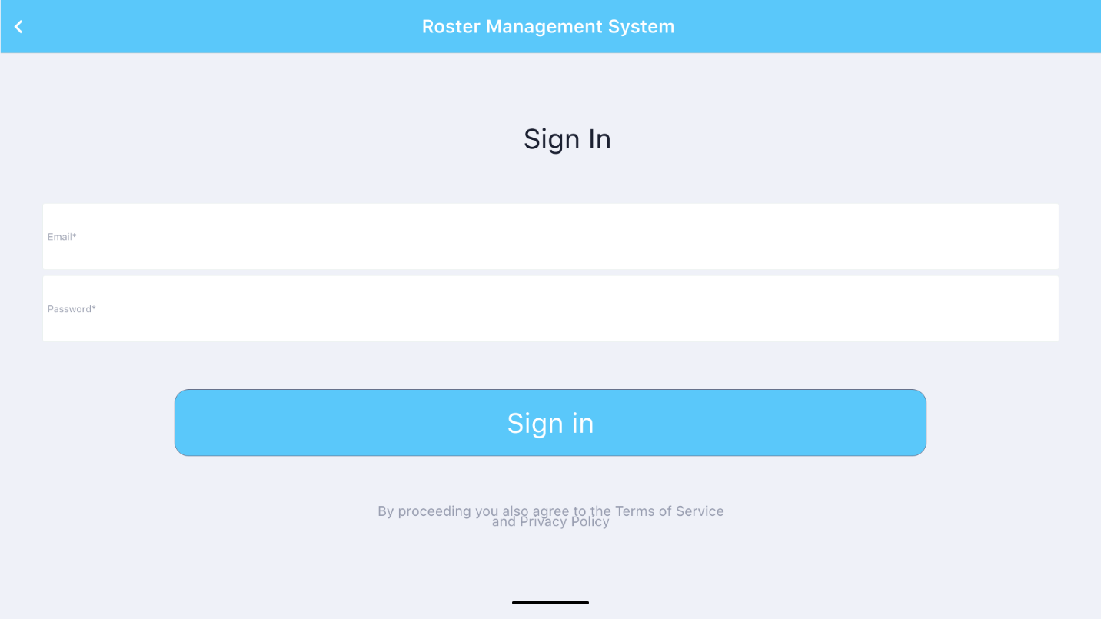

|  |  |
| --- | --- |
| Description: | This first page of application. user can sign in with password and Email which lead to main page or dashboard. |
| Content | Email and password |
| Navigation | The sign in button redirects the user to dashboard. If a staff sign in then it lead to employer dashboard where as if an admin sign in then it lead to admin dashboard |
| Graphic | The logo of an organization in the middle of page. |

1. Registration

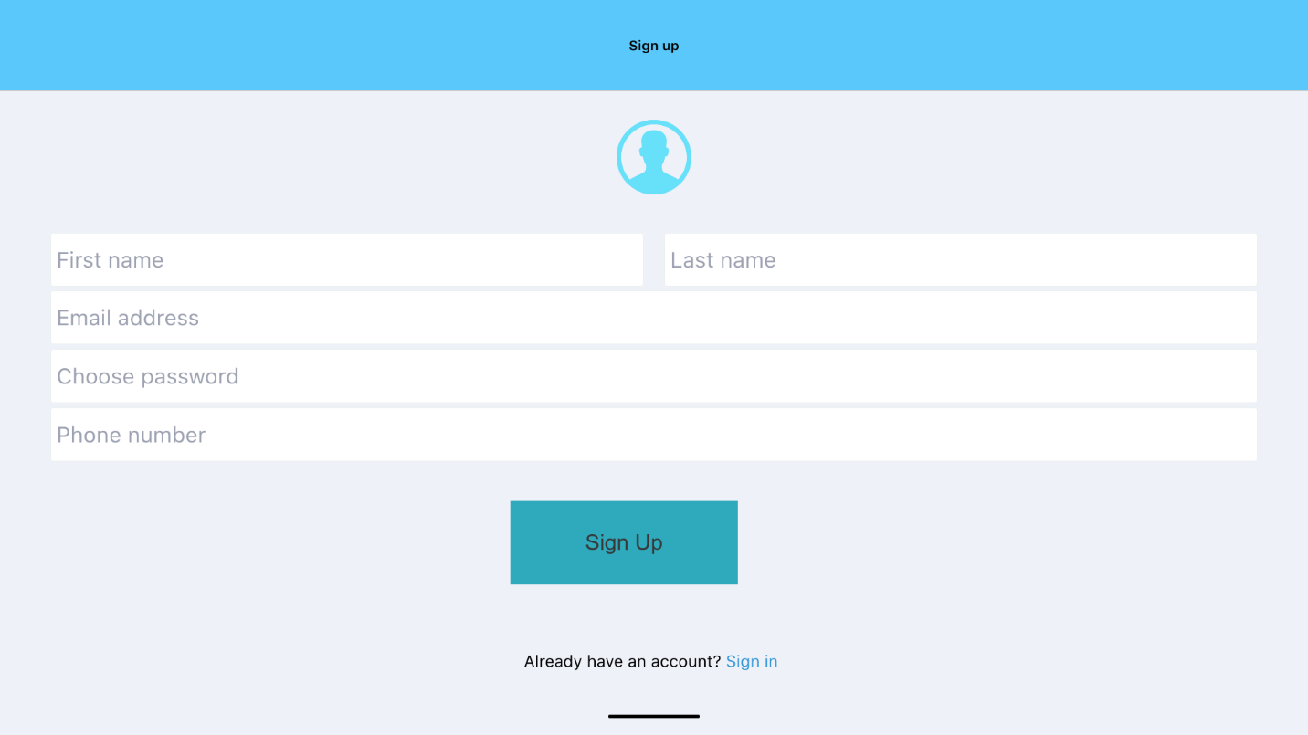

|  |  |
| --- | --- |
| Description: | This is sign up or registration page. New staff can first register in this page. |
| Content | First name, Last name Email, password and phone number. |
| Navigation | Clicking on sign up button register the account and redirects to sign in page. |

1. Staff Dashboard

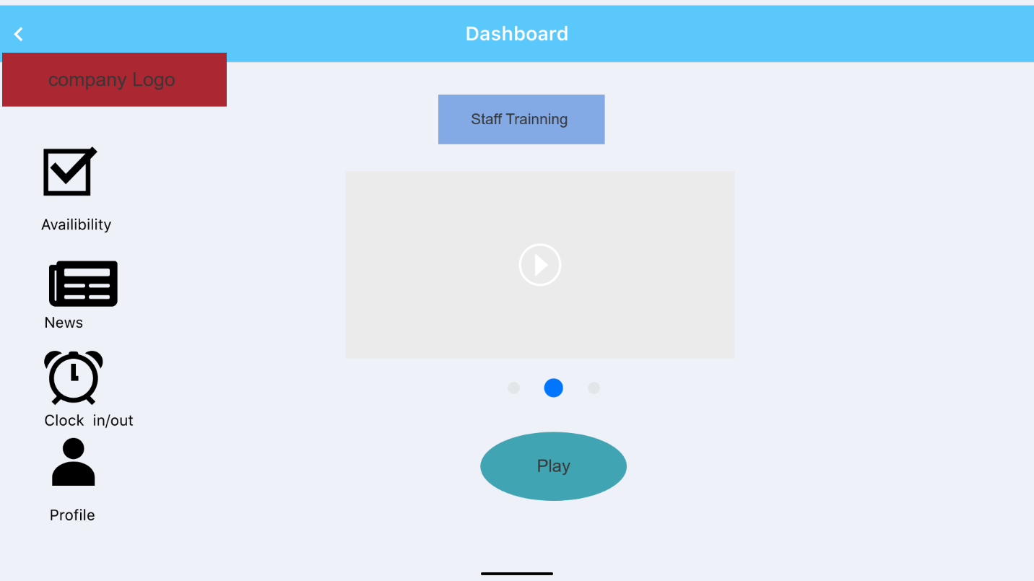

|  |  |
| --- | --- |
| Description: | This is staff sign Dashboard page. In this page staff can watch staff training video. |
| Content | . Click on play button to play video, can go to availability, news, clock in/out and profile. |
| Navigation | Navigation bar links to Staff Training, availability, news, clock in/out profile |
| Graphic | Company logo on top left side. |

1. Availability

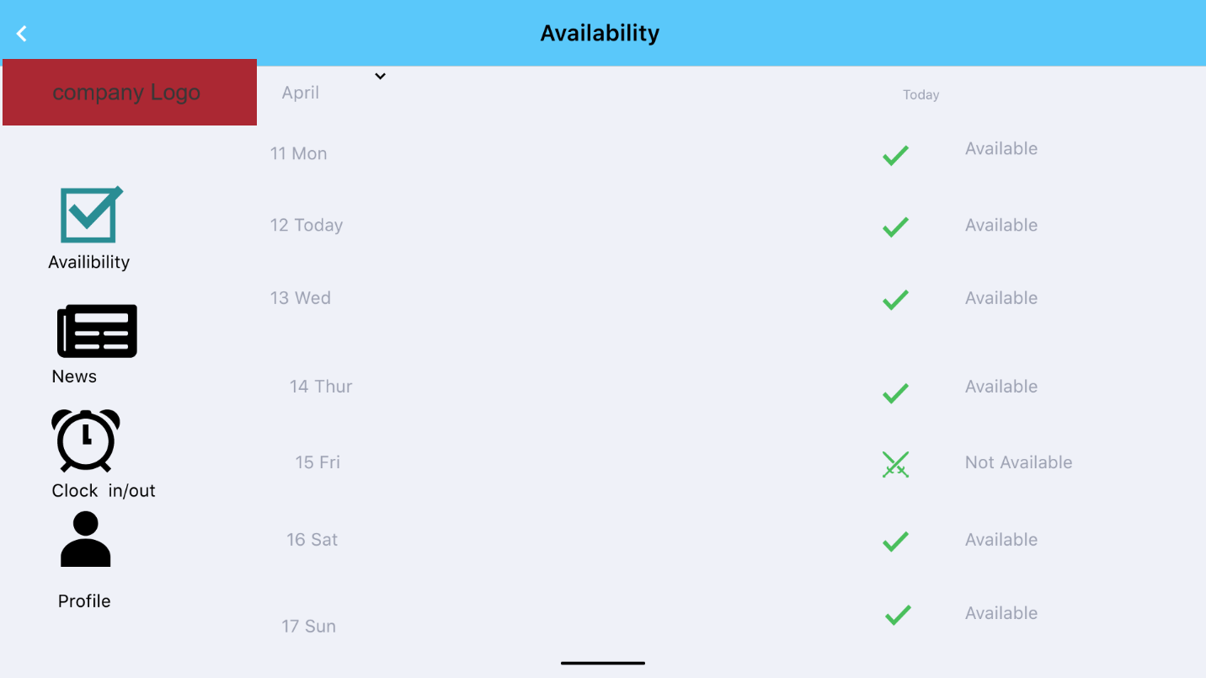

|  |  |
| --- | --- |
| Description: | Clicking on availability it lead to availability page. |
| Content | Clicking on date which is April it leads to month and staff can update their availability and unavailability by clicking on right hand side. |
| Navigation | Navigation bar links to Calendar, available date, time and unavailability, profile,news, clock in/out |
| Graphic | Company logo on top left side. |

1. Clock In/out

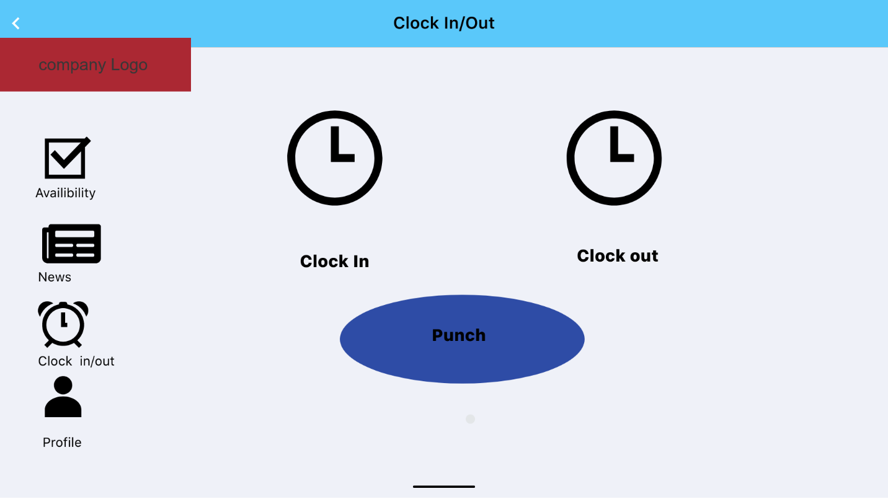

|  |  |
| --- | --- |
| Description: | Click on clock in /clock out menu then it will redirect to another page. where staff can click on clock in and punch at starting of shift and once shift is done staff can clock out and punch. The time between clock in and clock out punch will be recorded. Staff can clock in/out with in the company building, outside 500 meter range the system will show invalid. |
| Content | Clock in and clock out. |
| Navigation | where staff can click on clock in and punch at starting of shift and once shift is done staff can clock out and punch. The time between clock in and clock out punch will be recorded. Navigation bar links to Dashboard, availability, clock in/out, profile |
| Graphic | Company logo on top left side. |

1. News

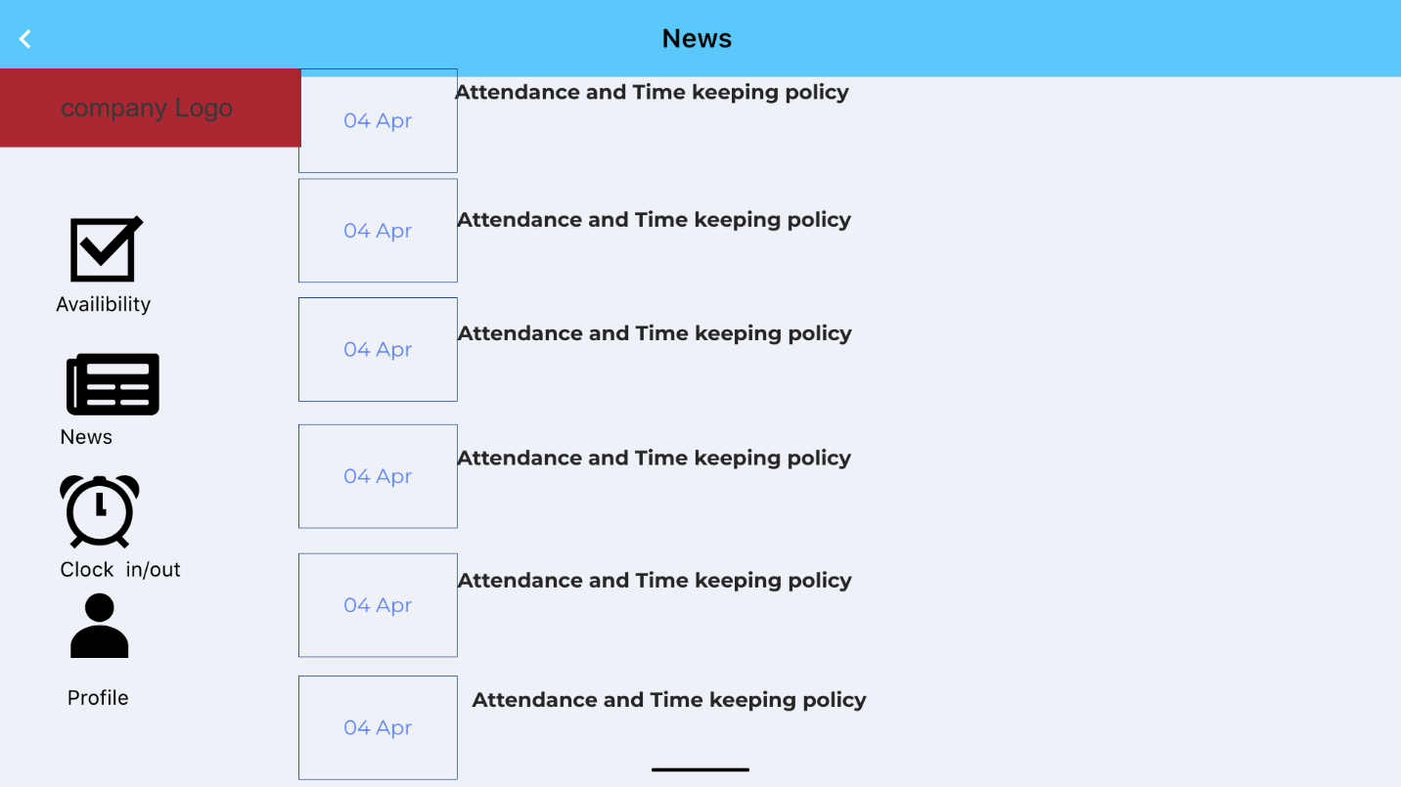

|  |  |
| --- | --- |
| Description: | Click on News bottom |
| Content | News/ announcement with update date. Any change in plan policy or update in company will be seen in news. |
| Navigation | Navigation bar links to Dashboard, availability, clock in/out, profile |
| Graphic | Company logo on top left side. |

1. Profile

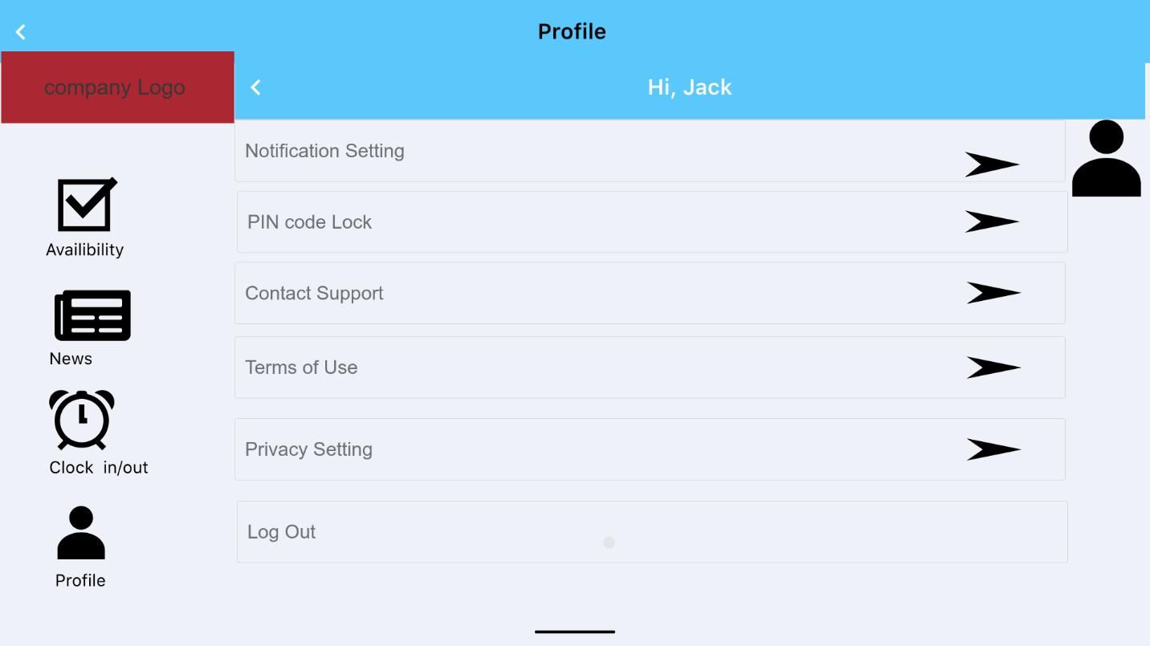

|  |  |
| --- | --- |
| Description: | Click on profile bottom |
| Content | Notification setting, pin code lock, contact support, terms of use, privacy setting and logout. |
| Navigation | Navigation bar links to Dashboard, availability, news, clock in/out, Notification setting, pin code lock, contact support, terms of use, privacy setting and logout. |
| Graphic | Company logo on top left side. |

1. Admin Dashboard

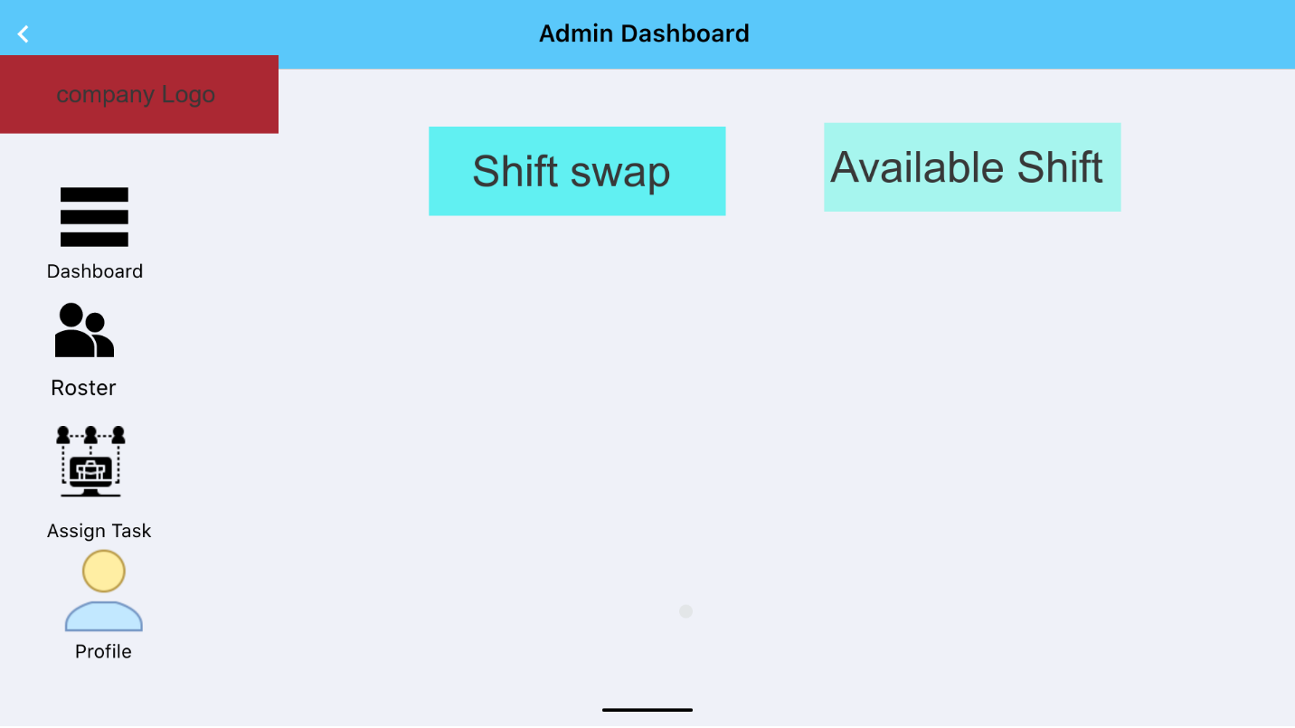

|  |  |
| --- | --- |
| Description: | Clicking on sign in button it will directly lead to Admin Dashboard. Admin can swap the shift among staff , delete shift, change and update |
| Content | A table with two column where admin can Shift swap, update available shift, delete shift. |
| Navigation | Navigation bar include the links to Admin profile, Assign task, profile and roster |
| Graphic | Company logo on top left side. |

1. Roster

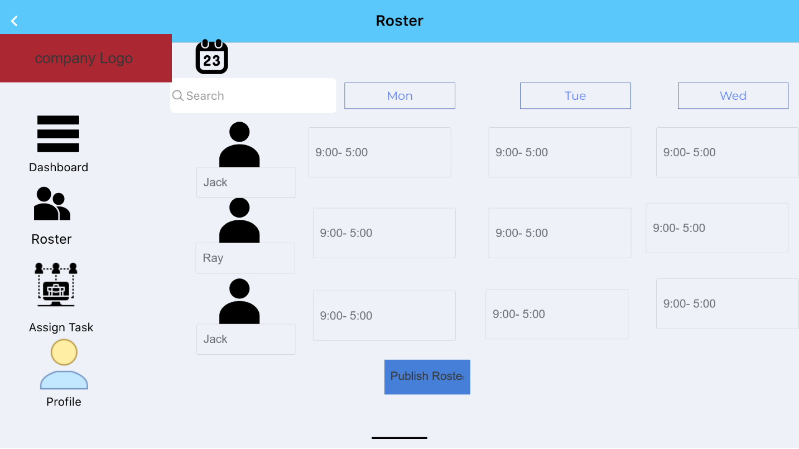

|  |  |
| --- | --- |
| Description: | Click on roster bottom |
| Content | A calendar shows the date, month and years. Search button where an admin can search for staff. Create roster for a week and publish. |
| Navigation | Navigation bar links to Dashboard, Roster (current page) Assign task , profile, calendar and search button |
| Graphic | Company logo on top left side. |

1. Assign Task

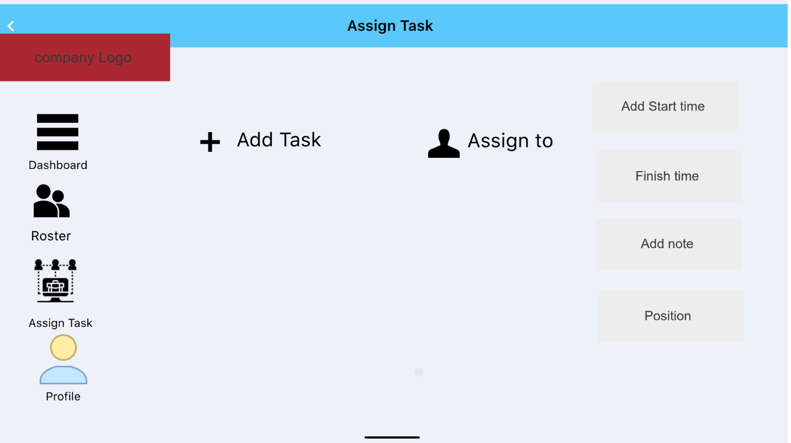

|  |  |
| --- | --- |
| Description: | Click on Assign Task bottom |
| Content | By clicking on add task admin can assign certain task with date, start time and finish time to specific staff according to availability of staff. They also can add note where the task is high priority, medium or low. |
| Navigation | Navigation bar links to Dashboard, Roster Assign task (current page) , profile, calendar and search button |
| Graphic | Company logo on top left side. |